Daniel Baumgartner

Mr. Parsons

Computer Science 210

22 June 2025

Corner Grocer – Design Analysis

This C++ program was created so that the Corner Grocer grocery store can easily track how many times a specific item (produce) was bought by a customer. The data is stored on a text file which is then read by the program. The program shows a display with four options that allow the user to find out what items and how many were purchased. Finally, the program saves the data in a backup file called frequency.dat.

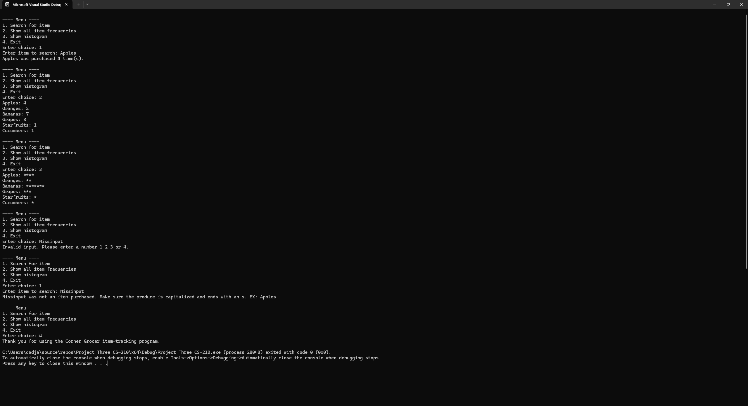

This screenshot shows the menu that the user will see upon using the program. It clearly shows the four options available to the user and accounts for if the user’s query is not an option or perhaps a typo (the last 2 prompts). The four options available are Search for a specific item which shows how many times it was purchased. Display a list of every item purchased and how many times they were purchased. Show a histogram that uses asterisks to show how many times an object was purchased. The last option allows the user to exit the program.

The program uses two parallel arrays; one stores the unique name data and the other stores how many times the items appear. The program can do this as it reads the text file line by line. If there is a new word, it adds it to the (string items) array. If already in this array and counted again, the program gives an extra count to the item via (int counts). This allows the user to search via name and number. The first part of the program, as shown in the image below, goes over parallel arrays.

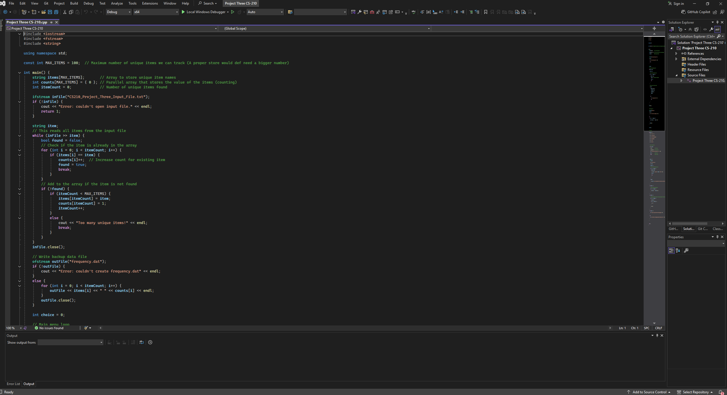

The second screenshot mainly goes over how the menu is formatted and how it is displayed. It also accounts for unavailable queries and the closing message. Image of the code shown below.

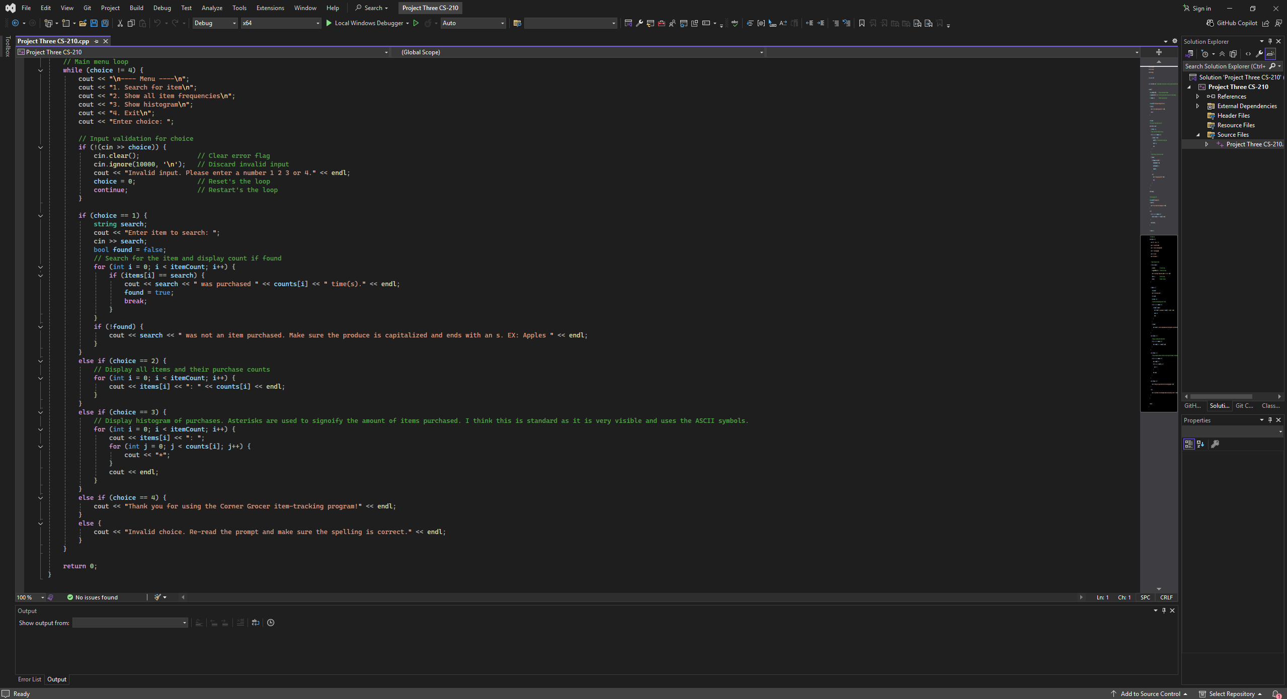

Additional information, the screenshot below shows the frequency.dat file where the information is stored, and the Input File which holds the grocery data that the program uses to display and read.

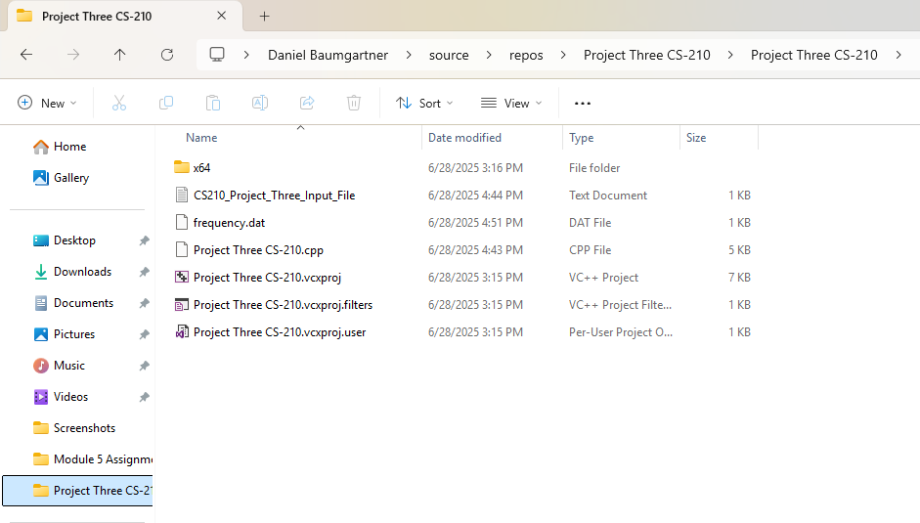

Thank you for choosing me to make this program. I know it will serve Corner Grocer well in their future and with their plans to re-arrange the layout of the store. If you ever need another program, just ask me and I will gladly help you out. Thank you again for this opportunity to work with you.